Canine Encounters

Course # 4065
Texas Commission on Law Enforcement
January 2016

Canine Encounters
Course # 4065
ABSTRACT

This guide is designed to assist the instructor in developing an appropriate lesson plan or plans to teach the course learning objectives. The learning objectives are the minimum required content of the Canine Encounters course. This course is a legislatively mandated course and is to be completed not later than the second anniversary of the date the officer is licensed and as a requirement for an intermediate or advanced proficiency certificate issued after January 1, 2016.
Note to Trainers: It is the responsibility of the coordinator to ensure this curriculum and its materials are kept up to date. Refer to curriculum and legal resources for changes in subject matter or laws relating to this topic as well as the Texas Commission on Law Enforcement website at www.tcole.texas.gov for edits due to course review.
Target Population: Licensed Peace Officers
Student Pre-Requisites: Licensed Peace Officer
Instructor Pre-Requisites: Certified TCOLE Instructor and/or a Subject Matter Expert
Minimum Length of Course: 4 hours
Methods of Instruction:
- Lecture
- Group Discussion
- Scenarios
- Equipment Demonstration
Assessment: Assessment is required for completion of this course to ensure the student has a thorough comprehension of all learning objectives. Training providers are responsible for assessing and documenting student mastery of all objectives in this course.

In addition, the Commission highly recommends a variety of testing/assessment opportunities throughout the course which could include: oral or written testing, interaction with instructor and students, case study and scenario, and other means of testing students’ application of the skills, as the instructor or department deems appropriate.
Reference Materials:
- House Bill 593
- Occupations Code 1701

Texas Commission on Law Enforcement
Canine Encounter Committee
Jason Hall – Committee Chair
League City Police Department

Tyler Harpole – Committee Member Stacy Kirby – Committee Member
Texas Department of Public Safety Texas Humane Legislative Network

William Kristoff – Committee Member Jim Osorio – Committee Member
Brazos County Sheriff’s Office Canine Encounters Law Enforcement Training

Daniel Looney – Committee Member Pat Burnett – Committee Member
Hunt County Sheriff’s Office Texas SPCA

Instructor Guide
Course Goals and Objectives

Course Title: Canine Encounters
Introduction:
1. According to the Humane Society of the United States (HSUS) and the American Pet Products Association (APPA) there are roughly 77.8 million canines in the United States, and 54.4 million canines in households that own at least one canine.
Instructor Note:
Source: http://www.humanesociety.org/issues/pet_overpopulation/facts/pet_ownership_statistics.html

2. Each year, more than 4.5 million people in the United States are bitten by dogs.

Instructor Note:
Source:
https://www.avma.org/public/Pages/Dog-Bite-Prevention.aspx

3. The list of dogs that are involved and reported in these dog bites or attacks can vary each year.

4. There are over 30 breeds of dogs that will be involved in a dog bite or attack each year.

Instructor Note:
Source:
http://www.dogsbite.org/dog-bite-statistics-studies.php

5. The Insurance Information Institute states that costs related to dog bites and their incidents have climbed into the billions of dollars each year.

6. You are more likely to encounter a dog in at least 1 out of 3 houses you visit.

Instructor Note:
Source:
http://www.iii.org/issue-update/dog-bite-liability

- Unit Goal: Texas State Animal Laws
1.1 Students will define terms utilized in the Texas Penal Code concerning laws pertaining to animals
Texas Penal Code
Definitions:

Deadly Force
“Deadly Force” means force that is intended or known by the actor to cause, or in the manner of its use or intended use is, capable of causing, death or serious bodily injury.

Reckless injury of innocent third person
Even though an actor is justified under this chapter in threatening or using force or deadly force against another, if in doing so he also recklessly injures or kills an innocent third person, the justification afforded by this chapter is unavailable in a prosecution for the reckless injury or killing of the innocent third person.

Civil remedies unaffected
The fact that conduct is justified under this chapter does not abolish or impair any remedy for the conduct that is available in a civil suit.

Elements of Cruelty to Animals

Cruelty to animals (§42.092- Non-Livestock)
(a) In this section:
(1) "Abandon" includes abandoning an animal in the person's custody without making reasonable arrangements for assumption of custody by another person.
(2) "Animal" means a domesticated living creature, including any stray or feral cat or dog, and a wild living creature previously captured. The term does not include an uncaptured wild living creature or a livestock animal.
(3) "Cruel manner" includes a manner that causes or permits unjustified or unwarranted pain or suffering.
(4) "Custody" includes responsibility for the health, safety, and welfare of an animal subject to the person's care and control, regardless of ownership of the animal.
(5) "Depredation" has the meaning assigned by Section 71.001, Parks and Wildlife Code.
(6) "Livestock animal" has the meaning assigned by Section 42.09.
(7) "Necessary food, water, care, or shelter" includes food, water, care, or shelter provided to the extent required to maintain the animal in a state of good health.
(8) "Torture" includes any act that causes unjustifiable pain or suffering.

1.2 Students will list examples of animal offenses per the Texas Penal Code

Cruelty to animals (§42.092- Non-Livestock)
(b) A person commits an offense if the person intentionally, knowingly, or recklessly:
(1) Tortures an animal or in a cruel manner kills or causes serious bodily injury to an animal;
(2) Without the owner's effective consent, kills, administers poison to, or causes serious bodily injury to an animal;
(3) Fails unreasonably to provide necessary food, water, care, or shelter for an animal in the person's custody;
(4) Abandons unreasonably an animal in the person's custody;
(5) Transports or confines an animal in a cruel manner;
(6) Without the owner's effective consent, causes bodily injury to an animal;
(7) Causes one animal to fight with another animal, if either animal is not a dog;
(8) Uses a live animal as a lure in dog race training or in dog coursing on a racetrack; or
(9) Seriously overworks an animal.

1.3 Students will discuss the range of punishment for animal cruelty and its defense to prosecution

Cruelty to animals (§42.092 Non-Livestock).
(c) An offense under Subsection (b)(3), (4), (5), (6), or (9) is a Class A misdemeanor, except that the offense is a state jail felony if the person has previously been convicted two times under this section, two times under Section 42.09, or one time under this section and one time under Section 42.09. An offense under Subsection (b)(1), (2), (7), or (8) is a state jail felony, except that the offense is a felony of the third degree if the person has previously been convicted two times under this section, two times under Section 42.09, or one time under this section and one time under Section 42.09.
d) It is a defense to prosecution under this section that:
(1) The actor had a reasonable fear of bodily injury to the actor or to another person by a dangerous wild animal as defined by Section 822.101, Health and Safety Code; or
(2) The actor was engaged in bona fide experimentation for scientific research.
(e) It is a defense to prosecution under Subsection (b) (2) or (6) that:
(1) The animal was discovered on the person's property in the act of or after injuring or killing the person's livestock animals or damaging the person's crops and that the person killed or injured the animal at the time of this discovery; or
(2) The person killed or injured the animal within the scope of the person's employment as a public servant or in furtherance of activities or operations associated with electricity transmission or distribution, electricity generation or operations associated with the generation of electricity, or natural gas delivery.
(f) It is an exception to the application of this section that the conduct engaged in by the actor is a generally accepted and otherwise lawful:
(1) Form of conduct occurring solely for the purpose of or in support of:
(A) Fishing, hunting, or trapping; or
(B) wildlife management, wildlife or depredation control, or shooting preserve practices as regulated by state and federal law; or
(2) Animal husbandry or agriculture practice involving livestock animals.
(g) This section does not create a civil cause of action for damages or enforcement of the section.

Instructor Note: Scope defined in Black’s Law Dictionary: The range of duties that an employee is expected to carry out in order to fulfil the requirements of the position.

1.4 Students will discuss terms and conditions utilized in the Texas Health and Safety Code concerning laws pertaining to animals

Sec. 822.041. DEFINITIONS. In this subchapter:
(1) "Animal control authority" means a municipal or county animal control office with authority over the area where the dog is kept or a county sheriff in an area with no animal control office.
(2) "Dangerous dog" means a dog that:
(A) makes an unprovoked attack on a person that causes bodily injury and occurs in a place other than an enclosure in which the dog was being kept and that was reasonably certain to prevent the dog from leaving the enclosure on its own; or
(B) Commits unprovoked acts in a place other than an enclosure in which the dog was being kept and that was reasonably certain to prevent the dog from leaving the enclosure on its own and those acts cause a person to reasonably believe that the dog will attack and cause bodily injury to that person.
(3) "Dog" means a domesticated animal that is a member of the canine family.
(4) "Secure enclosure" means a fenced area or structure that is:
(A) Locked;
(B) Capable of preventing the entry of the general public, including children;
(C) Capable of preventing the escape or release of a dog;
(D) Clearly marked as containing a dangerous dog; and
(E) In conformance with the requirements for enclosures established by the local animal control authority.
(5) "Owner" means a person who owns or has custody or control of the dog.

1.5 Students will identify factors that determine if a dog is considered dangerous

Sec. 822.0421. DETERMINATION THAT DOG IS DANGEROUS.
(a) If a person reports an incident described by Section 822.041(2), the animal control authority may investigate the incident. If, after receiving the sworn statements of any witnesses, the animal control authority determines the dog is a dangerous dog, it shall notify the owner of that fact.
(b) An owner, not later than the 15th day after the date the owner is notified that a dog owned by the owner is a dangerous dog, may appeal the determination of the animal control authority to a justice, county, or municipal court of competent jurisdiction. An owner may appeal the decision of the justice, county, or municipal court in the same manner as appeal for other cases from the justice, county, or municipal court

1.6 Students will review the requirements for an owner with a dangerous dog

Sec. 822.042. REQUIREMENTS FOR OWNER OF DANGEROUS DOG.
(a) Not later than the 30th day after a person learns that the person is the owner of a dangerous dog, the person shall:
(1) register the dangerous dog with the animal control authority for the area in which the dog is kept;
(2) restrain the dangerous dog at all times on a leash in the immediate control of a person or in a secure enclosure;
(3) obtain liability insurance coverage or show financial responsibility in an amount of at least $100,000 to cover damages resulting from an attack by the dangerous dog causing bodily injury to a person and provide proof of the required liability insurance coverage or financial responsibility to the animal control authority for the area in which the dog is kept; and
(4) Comply with an applicable municipal or county regulation, requirement, or restriction on dangerous dogs.

(b) The owner of a dangerous dog who does not comply with Subsection (a) shall deliver the dog to the animal control authority not later than the 30th day after the owner learns that the dog is a dangerous dog.

(c) If, on application of any person, a justice court, county court, or municipal court finds, after notice and hearing as provided by Section 822.0423, that the owner of a dangerous dog has failed to comply with Subsection (a) or (b), the court shall order the animal control authority to seize the dog and shall issue a warrant authorizing the seizure. The authority shall seize the dog or order its seizure and shall provide for the impoundment of the dog in secure and humane conditions.

(d) The owner shall pay any cost or fee assessed by the municipality or county related to the seizure, acceptance, impoundment, or destruction of the dog. The governing body of the municipality or county may prescribe the amount of the fees.

(e) The court shall order the animal control authority to humanely destroy the dog if the owner has not complied with Subsection (a) before the 11th day after the date on which the dog is seized or delivered to the authority. The court shall order the authority to return the dog to the owner if the owner complies with Subsection (a) before the 11th day after the date on which the dog is seized or delivered to the authority.

(f) The court may order the humane destruction of a dog if the owner of the dog has not been located before the 15th day after the seizure and impoundment of the dog.

(g) For purposes of this section, a person learns that the person is the owner of a dangerous dog when:
(1) The owner knows of an attack described in Section 822.041(2)(A) or (B);
(2) The owner receives notice that a justice court, county court, or municipal court has found that the dog is a dangerous dog under Section 822.0423; or
(3) The owner is informed by the animal control authority that the dog is a dangerous dog under Section 822.0421.

- Unit Goal: Recognizing and Understanding Canine Behavior

2.1 Students will define the word “ethology”.
- Ethology is the scientific and objective study of animal behavior. Experience and knowledge of dog behavior will help you predict how different dogs will respond to you. If you understand animal behavior, you will sometimes be able to guess what the animal will do next. Knowing the signs of different behaviors will help you decide how to handle the animal.

- Some animals may behave oddly because they have not been socialized. Just like people, animals that were neglected or abused when they were young may behave strangely when they are older. These animals are sometimes called asocial which means that they are not as friendly around people or socialized pets.

2.2 The student will be able to describe how at least two of a dog’s body parts are used in communication
Dogs are very expressive animals.
- They use body language to express when they are happy, sad, angry, excited or fearful.
- Dog body language is an elaborate and sophisticated system of nonverbal communication that we can learn to recognize and interpret.
- Dogs use facial expressions, ear set, tail carriage and overall demeanor to signal their intentions and feelings towards others.

The Eyes:
- Dogs rarely look directly into each other’s eyes because this is considered threatening behavior.
- A direct stare is much more likely to be a threat, and if you’re in close proximity to such a dog, it’s wise to slowly look away.
- If the dog doesn’t look directly at you, but instead looks out of the corners of his eyes so that you see a good deal of the whites of his eyes (the sclera), he might be leading up to an aggressive outburst. This look is known as “whale eye”.

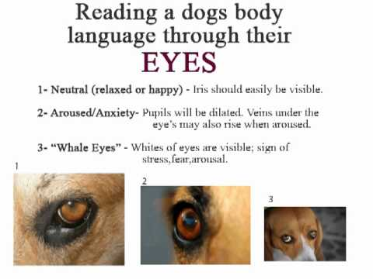
The Mouth:
- When a dog is relaxed and happy, he’s likely to have his mouth closed or slightly opened. If his mouth is open, he may be panting – this is how dogs cool their bodies. You might see his teeth because his mouth is slightly opened.
- A dog who’s frightened or feeling submissive probably has his mouth closed. His lips might be pulled back slightly at the corners. He might flick his tongue in and out, or he might lick if he’s interacting with a person or another animal.
- A dog who’s signaling his intention to act aggressively will often retract his lips to expose his teeth. He may pull his lips up vertically to display his front teeth while also wrinkling the top of his muzzle. This is typical of a dog who’s warning you not to come any closer.
- A dog may draw his lips back horizontally so that his lips are really tight at the commissure (the corners of the mouth). With this expression, you’re more likely to see both his front and back teeth (premolars and molars). This posture is often indicative of a dog who’s feeling afraid. However, once a dog is ready to bite, he usually pulls his lips up AND back so that his mouth is open and his teeth are exposed.

Instructor Note: Display pictures of different styles of mouths.

The Ears:
- When a dog is relaxed and comfortable, he’ll hold his ears naturally.
- When he’s alert, he’ll raise them higher on his head and he’ll direct them toward whatever’s holding his interest.
- A dog will also raise his ears up and forward when he’s feeling aggressive.
- If your dog has his ears pulled back slightly, he’s signaling his intention to be friendly.
- If his ears are completely flattened or stuck out to the sides of his head, he’s signaling that he’s frightened or feeling submissive.

Instructor Note: Display pictures of different styles of ears.

The Tail:
- People often assume that a dog with a wagging tail is a friendly dog, but this is not always the case. Dogs wag their tails for numerous reasons, including when they’re feeling aggressive. And a dog who isn’t wagging his tail can still be friendly.
- If he’s happy, he may wag it gently from side to side. If he’s really happy, like when he greets you after a long absence, his tail will wag more forcefully from side to side or might even more in a circular pattern.
- If a dog feels nervous or submissive, he’ll hold his tail lower and might even tuck it between his rear legs. He may still wag it from side to side, often at a more rapid pace than if he’s relaxed. If he’s really scared or feeling extremely submissive, he’ll hold his tail tucked up tight against his belly.
- If he’s standing his ground or threatening someone, he may “flag” his tail, which means he holds it stiff and high and moves it rigidly back and forth. It might look like he’s wagging his tail, but everything else about his body tells you that he’s not feeling friendly at the moment.

Instructor Note: Display pictures of different types of tails.

The Hair:
- Dogs may also signal their emotional state by raising their hair, which is called “piloerection,” or more colloquially, “raising the hackles.”
- Most often, this is the hair on their necks and backs.
- Dogs raise their hair when they’re aroused about something.
- It’s comparable to a person having goose bumps.
- Raised hackles can mean that a dog is afraid, angry, insecure, unsure, nervous or wildly excited about something.

Instructor Note: Display pictures of different types of hair.

Overall Posture:
- Dogs also use their bodies to communicate their intentions. In general, dogs either try to look normal, smaller or larger.
- If a dog’s feeling happy and contented, he’ll look normal – relaxed muscles and weight evenly balanced on all four feet. Similarly, when he’s playful, he’ll look normal. He may be bouncing around or running wildly with exaggerated movements, but his facial expression and his muscles will be relaxed and nothing about his body will look unnatural.
- When a dog is scared, he’ll be hunched over as though trying to look small. He might lower his body or even cower on the ground. His head will be held low as well. If he is frightened by something or someone, he’ll recoil away from it.
- A submissive dog looks very similar to a frightened dog because he makes himself look small to convey that he’s not a threat. If a dog is submissive, he’ll lower his body or even cower on the ground. His head might be raised, though, if he’s greeting a person or another animal. Lying down and presenting the belly is another way a dog may communicate their submission.
- An assertive (dominant), alert or aroused dog tries to make himself look large. His muscles will be tense. He’ll stand erect, sometimes even on his tiptoes, with his neck and head raised above his shoulders. His weight will either be centered over all four feet or he’ll be leaning slightly forward on his front legs.
- An angry, aggressive dog also makes himself appear larger than life to be as intimidating as possible. If a dog is aggressive, he’ll look very similar to an assertive, alert or aroused dog, but his posture will be accompanied by aggressive threats. Typically, his weight will be centered over his front legs so that he can lunge or charge forward rapidly.
- Your behavior when encountering a dog will also have a big effect on the outcome of the encounter. Officers should always watch their body language as well as the dog.

2.3 The student will be able to describe a dog’s body language using a visual depiction

Relaxed Approach:

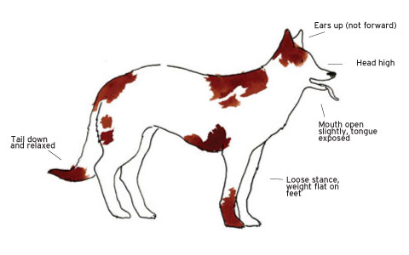
Instructor Note: This dog is relaxed and reasonably content. Such a dog is unconcerned and unthreatened by any activities going on in his immediate environment and is usually approachable. Still always use caution because just like us they can change their body language at any time.

Source: www.canineencounters.com

Alert:
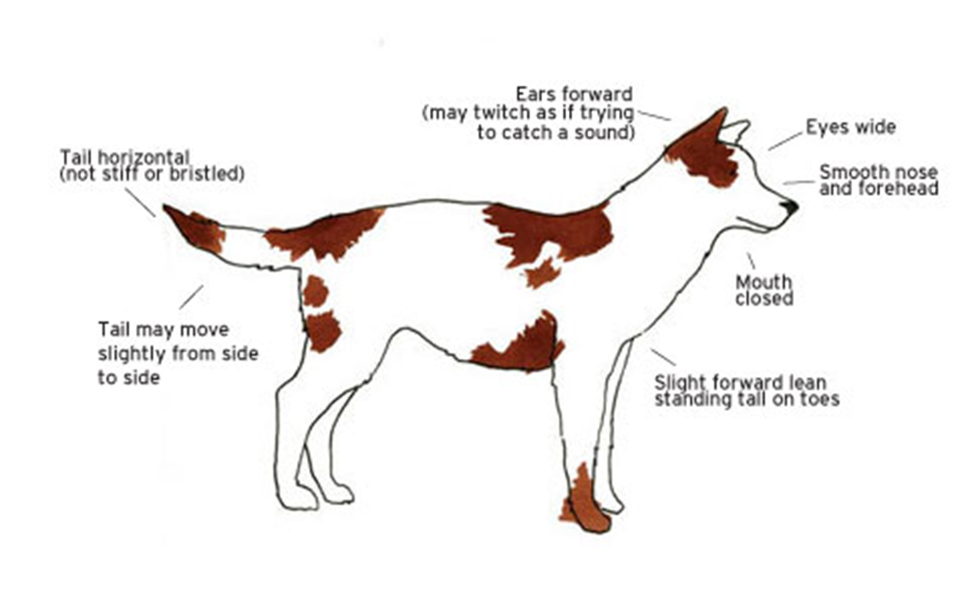
Instructor Note: If the dog has detected something of interest, or something unknown, these signals communicate that he is now alert and paying attention while he is assessing the situation to determine if there is any threat or if any action should be taken.

Source: www.canineencounters.com

Dominant Aggressive:
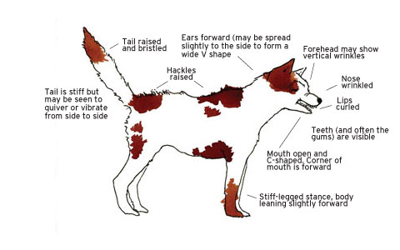
Instructor Note: This is a very dominant and confident dog. Here he is not only expressing his social dominance, but is also threatening that he will act aggressively if he is challenged. He is also demonstrating he is the leader, king of the pack.

Source: www.canineencounters.com

Fearful and Aggressive:
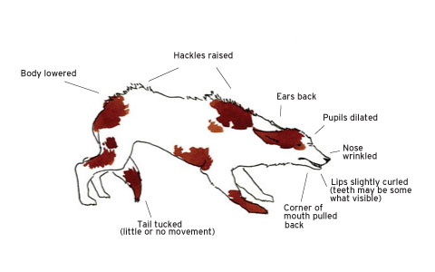
Instructor Note: This dog is frightened but is not submissive and may attack if he is pressed. A dog will generally give these signals when he is directly facing the individual or animal who is threatening him.

Source: www.canineencounters.com

Stressed and Distressed:

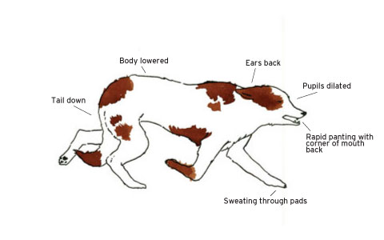
Instructor Note: This dog is under either social or environmental stress.
These signals, however, are a general “broadcast” of his state of mind and are not being specifically addressed to any other individual or animal.

Source: www.canineencounters.com

Fearful and Worried:

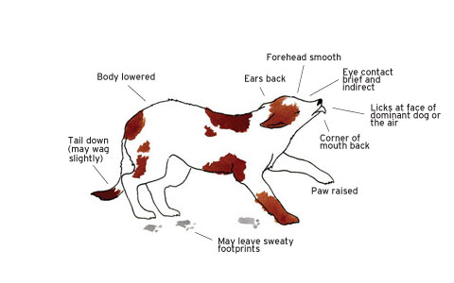
Instructor Note: This dog is somewhat fearful and is offering signs of submission.
These signals are designed to pacify the individual or animal who is of higher social status or whom the dog sees as potentially threatening, in order to avoid any further challenges and prevent conflict.

Source: www.canineencounters.com

2.4 The student will be able to list at least four types of dog aggression
Recognizing and understanding canine behavior types of aggressions in dogs:
Dominant Aggression
- This can be a dangerous or unpredictable type of dog that can intimidate officers.
- Usually only one person has control over this type of dog and officers should be careful when approaching.
- This type of dog also has a problem with strangers and usually does not discriminate. He could be friendly at times, and other times not.
- Never make the mistake of thinking this dog’s temperament is protective, this aggression can be very dangerous
Instructor Note:
This can be a dangerous or unpredictable type of a dog that can sometimes intimidate officers. Usually only one person has control (law enforcement or even criminals) over this type of dog and officers should be very careful when approaching. This type of dog also has a problem with strangers and usually does not discriminate; they could be friendly sometimes and sometimes not. Never make the mistake of thinking this dog’s temperament is protective; this aggression can be very dangerous. This type of aggression in dogs is being seen more and more in criminals that are using this type of canine for protection; officers should use extreme caution when approaching any individual who has this type of dog or is willing to use this type of a dog as a weapon to get away from officers.

SOURCE: www.canineencounters.com

Fear Aggression
- Handling fear aggression in a dog requires patience and consistent reinforcement and, in some cases, chemical immobilization.
- This dog is usually nervous, insecure and frightened most of the time.
- He usually reacts to almost any disturbances from radios, sirens and to approaching officers.
- Be ready for quick responses and try not to back this type of a dog into a corner if possible.

Instructor Note: Handling fear aggression in a dog requires patience and consistent reinforcement and, in some cases, chemical immobilization (last resort). This type of canine is usually nervous, insecure and frightened most of the time. They usually react to almost any disturbances from radios, sirens and to approaching officers. Be ready for quick responses and try not to back this type of a canine into a corner if possible. Animal Control Officers usually see this aggression a lot when they encounter a canine that they put in uncomfortable situations to control the canine.

SOURCE: www.canineencounters.com

Territorial Aggression
- Territorial aggression is a potentially dangerous behavior problem.
- If the officer is not intimidated, warnings may escalate to include hostile posturing and lunging.
- He can be a danger to any officer entering his domain and he could growl, lunge or even try to bite.
- When officers walk down the street, alley, and sidewalk or even onto someone’s property he can be aggressive or dangerous towards any officer approaching him.
- This dog could be a threat if you violate his space; use extreme caution when approaching this dog.

Instructor Note: Territorial aggression is a potentially dangerous behavioral problem. If an officer is not intimidated, warnings could escalate to include hostile posturing and lunging. They can be a danger to any officer entering their domain and they could growl, lunge or even try to bite. When an officer is walking down the street, alley, and sidewalk or even onto someone’s property they can be aggressive or dangerous towards any officer approaching them. This dog could be a threat if you violate their space, use extreme caution when approaching this type of dog. Most dogs have territorial aggression- even the most trained dog- when it comes to their yard, house or even car, but this this type of dog does not mean that they are aggressive or dangerous. Respect the warnings and you should be just fine.

SOURCE: www.canineencounters.com

Possessive Aggression
- Possessive aggression in dogs, also known as “Dr. Jekyll and Mr. Hyde,” is an undesirable and potentially dangerous trait that develops when a dog feels the need to protect his food, his companion, or another resource.
- He will bark, growl, bare his teeth, snap or even bite when any officer approaches anything that he may consider his.
- Approaching this dog when he has something in his possession like food or toys could trigger this aggression

Instructor Note: Possessive/Possession aggression in dogs, also known as the "Dr. Jekyll and Mr. Hyde," is an undesirable and potentially dangerous trait that develops in a dog when they feel the need to protect their food or another item. They could bark, growl, bare their teeth, snap or even bite when any officer approaches anything that they may consider there’s. Approaching this type of dog when he has something in his possession like food, toys or whatever could trigger this aggression. Most children are bitten by this type of aggression. A properly trained dog will not have this type of aggression and will allow even a complete stranger remove any item from their mouth without incident.

SOURCE: www.canineencounters.com

Punishment Aggression
- If an officer physically punishes a dog for growling, the dog may stop growling and proceed to bite.
- Growling is a dog’s way of warning us that he is uncomfortable and that if we don’t go away there could be trouble.
- Punishing this warning doesn’t make sense; we don’t want to prevent the dog from warning us he is about to fight.
- Officers can cause this form of aggression by being abusive or overly dominant when approaching this type of dog.

Instructor Note: Officers who physically punish a dog for growling can be dangerous; they may stop growling and skip right to the bite instead. Growling is a dog's way of warning us that they are uncomfortable and that if we don’t go away there could be trouble. Punishing this type of warning doesn't make sense; we don’t want to change the way the dog feels or even take away the warning that he is about to bite. Officers can cause this form of aggression by being abusive or overly dominant when approaching this type of dog. This is why you should never yell or scream at a dog, and always try to remain calm and talk to the dog in a firm tone of voice.

SOURCE: www.canineencounters.com

Pain Aggression
- Dogs can hide pain symptoms very well. Additionally, dogs can’t verbally tell us something may be wrong.
- Pain causes a dog to change behaviors to avoid the source of discomfort, so remember, just like us dogs have different degrees of pain tolerance.
- Remember when approaching an injured dog use extreme caution, they could try to snap or bite at you to try and stop you from touching him.

Instructor Note: Dogs can hide their pain symptoms very well; they also can't verbally indicate that something may be wrong. Pain causes a dog to change their behaviors to avoid the source of discomfort, so remember; just like us dogs have different degrees of pain tolerance. Remember when approaching an injured dog use extreme caution, they could try to snap or bite at you to try and stop you from touching him, this is why all dogs should be muzzled before touching or moving them.

Remember, a dog or any other animal that is in pain or injured can be very dangerous when trying to handle, use extreme caution when approaching an injured dog or animal. If one of these dogs or animals do bite, it’s most likely a bite that isn’t an intentional bite.

SOURCE: www.canineencounters.com

Predatory Aggression
- Predatory aggression is a normal part of dog behavior. Dogs are carnivores and predators; individual dogs all have some type of drive to chase and kill prey.
- There is no single cure or treatment for predatory aggression because it is a natural behavior.
- This dog usually attacks an officer who is moving away from them, and will chase any officer that turns or runs away from them.
- It can be a mistake for any officer who thinks they can just turn away and run from this attacking dog.

Instructor Note: Predatory aggression is a normal part of dog behavior, dogs are carnivores and predators, individual dogs all have some type of drive to chase and kill prey. There is actually no single cure or treatment for predatory aggression because it is a natural behavior. This type of dog will usually attack an officer who is moving and turning away from them, and will chase any officer. It can be a mistake for any officer who thinks they can just turn away and run from a dog. Dogs move much faster than people. You are better off standing your ground and seeing what the dog’s intentions are before turning away.

SOURCE: www.canineencounters.com

Maternal Aggression
- What self-respecting mother would not do all within her power to look after the welfare of her offspring?
- This aggression is most found in female dogs nursing or raising a litter of puppies.
- This aggression usually occurs when you approach her puppies. She could bark, growl or snap.
- This aggression usually stops completely when her litter is gone or on their own.

Instructor Note: What self-respecting mother would not do all within her power to look after the welfare of her offspring? This is most often found in female dogs nursing or raising a litter of puppies. This usually occurs when you approach her puppies; she could bark, growl or snap. This usually stops completely when her litter is gone or on their own.

SOURCE: www.canineencounters.com

Dog on Dog Aggression
- This usually occurs between dogs of the same sex.
- Dogs may be aggressive towards other dogs for a variety of reasons, including lack of socialization with other dogs.
- Fearfulness of other dogs.
- Protecting their territory or resources from other dogs.
- Barking, chasing, and growling, lunging and biting that is evident in mature dogs is generally seen in puppies during learning and playing.

Instructor Note: This usually occurs between dogs of the same sex. Dogs that fight are usually competitive and territorial and usually are focused on dominance versus submissiveness. Fear and territory are other influences in this type of aggression. Barking, chasing, and growling, lunging and biting that is evident in mature dogs is generally seen in puppies during learning and playing. Anyone who owns more than one cog sometimes see’s this with their own dogs when playing.

SOURCE: www.canineencounters.com

Redirected Aggression
- If you interrupt a dog’s aggression behavior toward another person or an animal and the dog barks at, snaps at, growls at or bites you, this is considered redirected aggression.
- This can happen to anyone who tries to interfere when a dog is about to attack or is already in the fight.

Instructor Note: If you interrupt a dog's aggressive behavior toward another person or even an animal and the dog barks at, snaps at, growls at or bites you, this could be considered redirected aggression. This happens to anyone who tries to interfere when a dog is about to attack or is already in the fight. So any officer should always be careful when interrupting a dog that may be concentrating on something else other than the officer. Who knows, maybe the dog is telling the officer there is another problem he is looking at and that the officer should be concerned about that.

SOURCE: www.canineencounters.com

- Unit Goal: Non-lethal tools/methods/resources to avoid and defend against canine attack

3.1 Describe the usage of on-scene awareness when approaching a situation involving a canine call

- Officer Awareness
  - When approaching a call the officer needs to be aware of his/her surroundings:
    - Look for signs of a canine on the property
    - Canine houses
    - Chains in the yard
    - Worn patches or trails in the yard
    - Food or water bowls on the porch
    - Doggie doors (the size of the doggie door is directly proportional to the size of the canine)
    - Look for pet toys, items that appear to have been chewed or torn, holes or other indications of digging.
- Check for Presence of Canine(s)
  - If yard is not fenced:
    - Call out for canine
    - Beat on the side of the door
    - Honk the horn
    - Whistle
  - If yard is fenced:
    - Rattle gate
    - Call out for canine
    - Whistle
    - Knock on the side of the house if reachable

- If Canine Is Present
- Yard with no fence:
  - Give canine commands (sit, back, stay)
  - Underhand toss some canine treats, if only one dog
  - Honk your horn to get the owner’s attention
- Yard with fence:
  - Underhand toss canine treats, if only one dog
  - Give canine commands
  - Call out for owner
  - Honk horn
- If the owner is present, ask the owner to secure the canine
- If the owner is not present:
  - Have dispatch attempt to contact owner
  - Use a distraction tool
  - If there is enough time contact Animal Control Services directly, or ask dispatch to send an Animal Control Officer

Reactionary Gaps for Dogs
When you are entering an animal’s home range, remember that all animals have a “flight reaction distance.” This is the closest you can get to that animal before causing a reaction. The animal will either attempt to run, fight, or play. Most animals will try to run and avoid a confrontation instead of fighting when you approach them. This is the “flight” response if given enough room most dogs will choose this. If you enter the animal’s critical distance, it will usually attack you in an effort to escape. Reduce the chances of the animal attacking you by understanding how animals will react to your proximity.
- Home Range
  - This is the largest area in which the animal will usually roam.
  - This area will vary depending on the size, age, and behavior of the animal.
- Territory
  - This is a smaller area within the home range, and the animal usually decides to defend or flee from intruders.
- Public Space
  - This area is greater than 12 feet from the animal, but it is still within the animal’s territory. When you approach an animal in this area, the animal will usually try to run from you.
  - For a dog, this is your interview distance- around 12 feet.
- Social Space
- This is a smaller area, approximately 4 to 12 feet, within the public space. When you approach an animal in their social space, they may either fight or run from you, depending on other social behavioral characteristics.
- Personal Space
- The Personal Space is approximately 0 to 4 feet. This is the smallest area, and the area nearest the animal. When you approach an animal in their personal space, they will usually fight or submit. This space can vary depending on the size of the dog.

3.2 Describe the utilization of common tools carried by law enforcement in the non-lethal control of canines

Tools and Methods/Common Tools

- Tools carried by an officer on his duty belt and in his patrol vehicle can be used to deter a canine from attacking.
- These tools should be used to help the officer retreat to a safe point to reassess the situation.
- Proper use of these tools give the officer the ability to humanely handle the canine in any situation.

Tools
- Officer’s Voice
  - In any situation with canines, an officer must maintain a calm, commanding voice. An officer will use this on initial contact with a canine. The canine may be slowly approaching, mouth closed, eyes wide open, head turned but still watching you.
- Remain calm, give simple commands
  - Never stare
  - Most canines understand sit, no, stay with an outstretched arm
  - Try commands in Spanish, Sit/Sentarse, No/No, Stay/Estancia
  - If an owner is present, direct the owner to confine their canine
- Distraction Tools
  - A distraction tool is a moving object kept between the officer and the canine. This will be used if the canine is continually moving closer as the officer is backing away.
  - An ASP, baton, or flashlight can be sued as a distraction tool, keeping it between the officer and canine. Continually move the tool in front of the animal to take their attention off the officer.

  - Identify tools of opportunity (items found at the scene)

- Other Distraction Tools At The Officer’s Disposal
  - Clipboard
  - Traffic cone
  - Jacket
  - Stick
  - Garbage can
  - Anything to keep between the officer and the canine until the officer can reach a place of safety
  - Another distraction tool is a CO2 fire extinguisher. Most SWAT teams are now carrying these for building entries.

- Impact Tools
  - Any of the distraction tools can be used as an impact tool, but caution must be taken where to strike the canine. The use of these tools can result in a deadly force action.
    - Minimal Trauma level: except for the head, neck, and spine most of the canine’s body may be struck. The injuries tend to be temporary, although exceptions can occur.
    - Moderate to Serious level: Chest, ribs area, groin, and leg joints. Injuries tend to be more long lasting.
    - Serious Trauma Level: Highest level of serious trauma. The Head, Neck, and Spine injuries range from serious to long-lasting rather than temporary. May include unconsciousness to serious bodily injury.
- Chemical Spray
  - Chemical spray should be used when the canine is circling the officer, making fast hit and run attacks in close, or the officer is backed into a corner.
  - The officer should use his/her weak hand to administer the OC Spray, keeping the dominant hand ready to use other tools available.
- Electronic Tools (Taser)
  - Because of a canine’s size, it is hard to use a Taser at extended ranges.
  - Since a canine’s body is horizontal, when deploying a Taser it should be tilted to the side so the probes will spread sideways.
  - Use the Taser when you are unable to use deadly force due to surroundings and potential for hitting bystanders.

3.4 Demonstrate humane methods in approaching, controlling, and subduing canines

Instructor Note: Utilization of scenario role-play should be applied to fulfill this objective. Students will be required to participate in this activity and assessment made by instructor per performance of skill.
- Unit Goal: Conflict Avoidance, De-escalation, and Use of Force Continuum Principles

4.1 Identify Canine Conflict Avoidance Techniques

Dogs are extremely adept at reading human body language. They can quickly read human behaviors that portray safety as well as threatening. Dogs in turn respond to these human behaviors by communicating with their own body postures, facial expressions, and vocalizations. When approaching a dog, the officer should subtly gaze at its body stance to get an overall impression of the dog’s state of mind. However, never stare at the dog’s face. This eye contact can create a challenge.

When encountering a dog, officers should:
- Stop all forward movement
- Turn their bodies to the side.
- Drop their gaze and watch the dog using peripheral vision (Under no circumstances should an officer stare at a dog).
- Speak calmly to the dog, simultaneously scanning the surroundings for escape routes in case of an escalated event.
- Verbal cues (“Sit” in a pleasant tone and then tossing treats)
- Most importantly, never run. A human cannot outrun a dog and they may respond by chasing, seeing it as play, but injury could still occur.

4.2 Demonstrate the usage of Canine Conflict Avoidance techniques

Instructor Note: Utilization of scenario role-play should be applied to fulfill this objective. Students will be required to participate in this activity and assessment made by instructor per performance of skill.

4.3 Discuss De-escalation techniques in working with canine calls

Even though dog behavior can be complex, simple strategies can keep officers safe in most of their encounters with dogs.
- Strategy 1: Turn the body to the side, downward gaze, and keep hands close to the body. This technique says “I’m no threat” to the canine. It’s the best way to handle dogs that approach in a non-threatening manner and to prevent fearful signals from escalating to warning signals and warnings from escalating to bites. To the over-enthusiastic animal it does not show excitement and the dog soon loses interest.
- Strategy 2: Avoid excessive movement. Move slowly and smoothly in order to give him a chance to back away. Most importantly, always be aware of the signals he’s sending you with his body language as you approach. Are his eyes darting back and forth or is his gaze looking away while he’s crouching submissively? Or is he yawning, flickering his tongue in and out of the front of his mouth, or panting with his lips drawn back to the sides? These are signs of conflict or anxiety. In all of these situations give the animal space.

Instructor Note: Although the following strategy (3) is a useful strategy, it may not be feasible to carry treats with you at all times. But it is a viable de-escalation technique.

- Strategy 3: Use of treats to prevent and defuse threatening canine encounters. Using a smooth underhand motion (an overhand throw is likely to be perceived as an impending blow) toss a handful to a dog at a distance. The food will scatter and take the dog a bit of time to collect it all. This simple technique can distract the animal and possibly win them over. It is an effective de-escalation tool and further gives us information; a dog that will not eat treats is a frightened animal. Do not use this technique when multiple dogs are present. Competitive nature will override the de-escalation that was hoped for.

Instructor Note: Have students brain storm additional de-escalation techniques to utilize when encounters canines in the field.

4.4 Demonstrate the usage of Canine De-escalation techniques

Instructor Note: Utilization of scenario role-play should be applied to fulfill this objective. Students will be required to participate in this activity and assessment made by instructor per performance of skill.

4.5 Examine the Use-of-Force Continuum Principal

Instructor Note: It is recommended that agencies consider developing a use of force policy for animals.

Officer Presence (Calm Behavior)
- Canine’s Actions
  - Protecting their territory and or owner by barking inside or outside.
  - Element of surprise behavior (Canine is startled).
  - Almost all dogs will try to bluff or threaten an intruder away before resorting to actual contact.
- Officer’s Actions
  - Mentally prepare yourself. Have a mental picture of what you are going to do in the case there is a canine.
  - Make your presence known.
    - Rattle the gate.
    - Beat on the door of the car.
    - Whistle or call out to the canine.
  - Anticipate the presence of a canine.
  - Some officers carry canine treats.
  - Evaluate your body language. Blade your body away with weak side facing the canine

Verbal Commands
- Canine’s Actions
  - Confrontation
  - Mouth tensed and closed
  - Approaching slowly
  - Head turned but still looking at you
  - Eyes wide open
  - Tail slowly wagging, tail stiff or tucked in between his legs
- Officer’s Actions
  - Stand still or slowly move backwards
  - Use a normal but firm voice
  - Give simple commands (most canines understand sit, no, etc.)
  - Try commands in Spanish, Sit/Sentarse, No/No, Stay/Estancia (some canines with attack training are taught commands in German)
  - Direct owner if present to confine canine

Distraction Devices
- Canine’s Actions
  - Enters your social space, 4 to 12 feet
  - Gaining confidence to bite by coming closer and closer while you are backwards
  - Direct eye contact that becomes tunnel vision
- Officer’s Actions
  - Straight baton
  - ASP
  - Flashlight
  - Clipboard
  - Stick
  - Umbrella
  - Air horn
  - Fire Extinguisher
  - Other

Chemical Spray
- Canine’s Actions
  - The canine is circling you
  - Canine makes fast and direct approaches
  - Canine puts you into a corner
  - Canine bites and retreats, this is the hit and run method
- Officer’s Actions
  - Recommend you use your weak hand to use OC Spray while your dominant hand is ready for strikes, walking slowly backwards

Continuously Moving Target
- Canine’s Actions
  - Lunging forward to attack
  - Charges you without slowing down
  - Might be barking or not
- Officer’s Actions
  - Always present a continuously moving object, a straight baton, ASP, Flashlight, Clipboard, something you pick up, etc.

Strike or Impact Weapon
- Canine’s Actions
  - The overwhelming majority of dog bites are minor.
  - When a bite has occurred and the dog continues to bite (rather than biting and then immediately retreating), or a bite clearly cannot otherwise be avoided and the dog is large enough to inflict significant injury, defensive options may be needed.
  - Bites and grips clothing of body
  - Bites then circles or stands ground
  - Prior history of the canine biting
- Officer’s Actions
  - Defensive options should be effective, safe and humane, easily deployable, acceptable or defensible to the observing public, and no risk to the observing public
  - Strike or impact weapon may be used if there are bystanders and you are unable to use deadly force due to your surroundings or potential of hitting victims
  - Batons, flashlights, clipboards, etc. should be as distraction device on aggressive canines, and the officer should always remain calm and present a continuously moving object to the animal, making the animal concentrate on the object, not the officer. Care should be taken where the animal is struck if these are to be used as an impact weapon
  - When using a Taser, tilt it to the side to spread the probes sideways. A Taser can cause serious injury or death to an animal and so should be used sparingly.

Deadly Force
- Canine’s Actions
  - Bite continuously gripping the body
  - Direct charge with no hesitation
  - Active aggressive pack
- Officer’s Actions
  - Shoot the canine in the middle of the shoulders or spine area
  - Witness to an attack and/or Body Cam
  - Be able to articulate what happens
  - Be aware of your surroundings at all times to prevent unintentional injury or death

4.6 List what should be done if deadly force must be used

If Deadly Force Must Be Used (Recommended)
- Treat This As Any Other Deadly Force Encounter
  - Photo area
    - Photos of whole scene giving a perspective of the distance between officer and dog when shot (photo of shell casings in relation to the dog)
    - If dog ran after being shot, indicate location dog was then shot
    - Photos of dog
    - Places any bystanders were standing
  - Detail Report
    - Contextualize observations of the function of the dog
      - Environment
        - How dog is contained
          - Kennel
          - Chained
          - Loose in house with family
  - Relationships in which the dog lives
- Description of Dog
  - Do not specify breed- stay with basic color, size, sex.
  - Using specific breed descriptions gives attorneys the opportunity to examine your report. If the dog was not a pit-type dog and you describe the dog as one, the remainder of your report will be critiqued and questioned for accuracy.
- Follow All Agency Protocol For Discharging A Weapon

- Unit Goal: Other Techniques and Surviving an Attack

5.1 Students will be able to describe other methods for handling a canine

Other Techniques
Caring For Injured Canines
- Muzzling
  - With a four-foot piece of small rope or gauze make a surgeon’s loop (double knot) in the middle.
  - Lace loop over dog’s nose and pull snug.
  - Pull ends under dog’s mouth and tie with an overhand knot.
  - Pull ends to the back of the dog’s head and tie in a square or reefer’s knot.
- Moving Injured Dog
  - After muzzling the dog, lay a large towel or blanket next to the animal
  - You may need some help to slide the animal on the towel or blanket
  - The improvised stretcher can be picked up by the corners
  - Try to use a towel or blanket large enough that when the edges are brought together the dog’s head will be inside the folds

5.2 Students will demonstrate the method of muzzling a dog

Instructor Note: Utilization of scenario role-play should be applied to fulfill this objective. Students will be required to participate in this activity and assessment made by instructor per performance of skill.

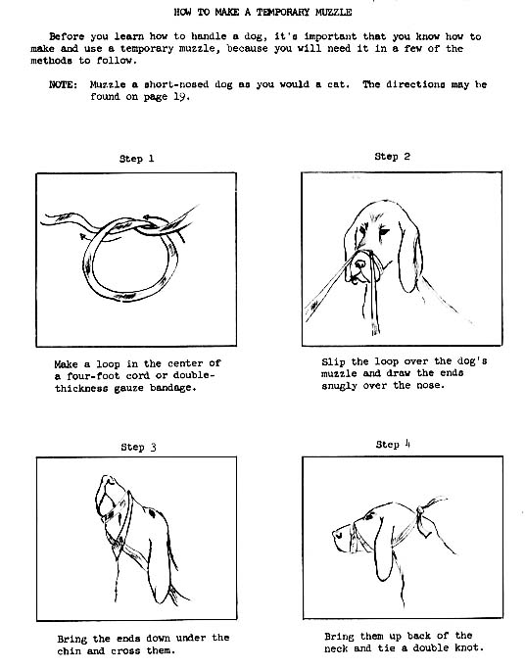

5.3 Students will be able to discuss additional techniques to use to survive a canine attack

Surviving the Attack
Force continuum principles can be applied to dogs. Officers should understand that no single dog presents a plausible risk of fatality to an able-bodied adult accompanied by other humans. In fact, only a very few dogs of the very largest types can match the force potential of even an unarmed human.

The use-of-force continuum as it relates to animals: physical presence, verbal commands, mechanical repellants (baton, bite stick), improvised dog repellants, chemical repellants, electronic repellants (stun gun, Taser), physical capture, chemical capture, and deadly force.

Allow a dog owner or animal control officer, whenever the owner or an animal control officer is present and it is feasible, the reasonable opportunity to control or remove a dog from the immediate area in order to permit a law enforcement officer to discharge his or her duties.
- Cease all forward movement and turn to the side, keeping arms at sides, to appear less threatening to the dog. Never stare.
- Speak calmly to the dog in a friendly tone while scanning the surroundings for escape routes that will not bring the officer closer to the dog and for barriers that can be used for protection in case of escalation.
- Do not yell or scream, and never run.
- Brace yourself:
  - A canine attacking at a full run is no match for a human.
  - Stay calm and loose, bracing yourself just before impact.
  - Try a side stepping maneuver to avoid impact.
- If the canine gets your hand, shove it as far into their mouth as you can. Avoid the impulse to pull away. Such an action can increase injury, changing a less serious puncture into a deep laceration.
- Canines move faster than people do.

The Stand Off
- The stand-off is nothing more than picking up something and placing it between you and the canine. The bigger the object the better, but use whatever you can get at the time. Do not use something that will be too heavy. It will fatigue you, plus it will restrict your ability to use it effectively. If you’re lucky, the object will not only shield you from the canine but will also startle her. This may give you enough time to retreat.
- Also try to place your back against something. While this will reduce your mobility, it will also reduce the directions the canine can attack from.
- Verbal commands such as “stop”, “bad dog”, “sit”, and “down” should be attempted at this time, as well as calling for assistance.
- If you find yourself in a stand-off, call for assistance.

Throwing Something
- While this will not stop a canine from attacking (unless you’re very good at throwing), it may give you a fraction of a second to plan another course of action.
- You might get lucky enough to get a canine with a very strong “fetch drive,” like those canines that are addicted to those balls and Frisbees in the parks. Hopefully, the canine will switch course but don’t depend on this with a charging canine.
- If you choose this option, try sand, dirt, medium sized rocks, keys, change, water, and the best option, food, if you happen to have some.

Punching and Kicking
- For the most part punching and kicking a canine is pointless.
If The Canine Gets You on the Ground
- Protect throat and ears. Use your hands, do not expose fingers, it is best to ball your hands so the animal cannot bite at your fingers.
- If you have to offer something, it is recommended you use your weak side hand with something in it, if need be your weak side arm wrapped in a jacket to give you access to all the tools at your disposal on your belt, (ASP, OC Spray, etc. anything available) .

INJURED CANINE (K-9) HANDLER
If any Canine (K-9) Handler becomes incapacitated or injured and is unable to handle his Canine (K-9), officers at the scene should:
- If possible, have the K-9 Handler call his dog.
- Attempt to call the K-9 to a marked patrol unit, preferably the K-9 vehicle, if possible; using the phrase the K-9 Handler would use to load his K-9.
- Attempt to get another K-9 Handler to handle the K-9 .If necessary, contact animal control authorities quickly to avoid the K-9 escaping or being injured.

6.0 Unit Goal: Other Animals in the State of Texas
During the course of your daily duties you may come across other types of animals. If you are not trained or comfortable around such animals, you should contact your local animal control services to assist you in the proper handling of these animals.

6.1 Students will identify other common animal encounters

Instructor Note: Instructor should research animal encounters in your specific region and list these encounters to discuss with local departmental cases and their solutions.

Other Sources available to law enforcement officers.
Texas Animal Control Association
http://www.taca.org/

Texas Parks & Wildlife Department
http://tpwd.texas.gov/

